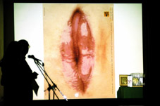

One of last year´s winners “Lips” (Park Saatchi)

Summary Form
This form is to list all entries and to calculate entry fees. It must be sent together with the entries and entry forms to: LEAF advertising festival.

or email: leaf@prisma-mag.com or editor@prisma-mag.com

Company: ........................................................................................................................................................

Address:...........................................................................................................................................................

City &Postcode:...............................................................................Country:..................................................

Telephone: ..................................Fax:.............................................Email :.....................................................

Name of Person Making Entry: ......................................................................................................................

Name of Executive Creative Director: ............................................................................................................

2. MATERIAL ENTERED
Category Number | Name of Product or Service Advertised | Number of Items Entered |  | Entry Fees  (120 euros each)
 |  | TV | Press Ads & Posters | € 120
 | Please add company registration fee |  |  | € 230
 | Total |  |  | €

3.AUTHORIZATION
I have read the LEAF Competition rules and hereby agree to comply with them (obligatory for all entrants).
Date:.............................................................................Signature:...................................................................

LEAF:FESTIVAL
email: leaf@prisma-mag.com or editor@prisma-mag.com or prisma@prisma-mag.com www.prisma-mag.com

